Figure-1.1. Verilog Source code for 2-to-1 Multiplexer
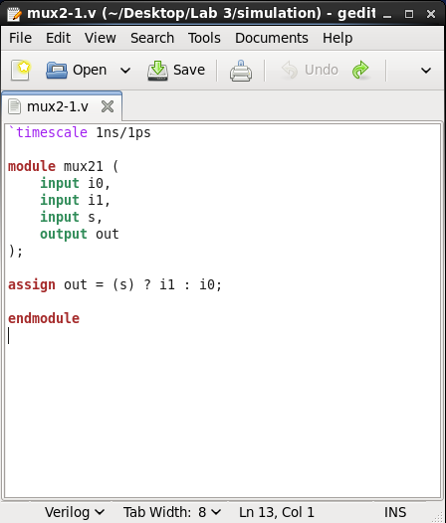

Figure-1.2. Verilog Source code for 2-to-1 Multiplexer Test-bench
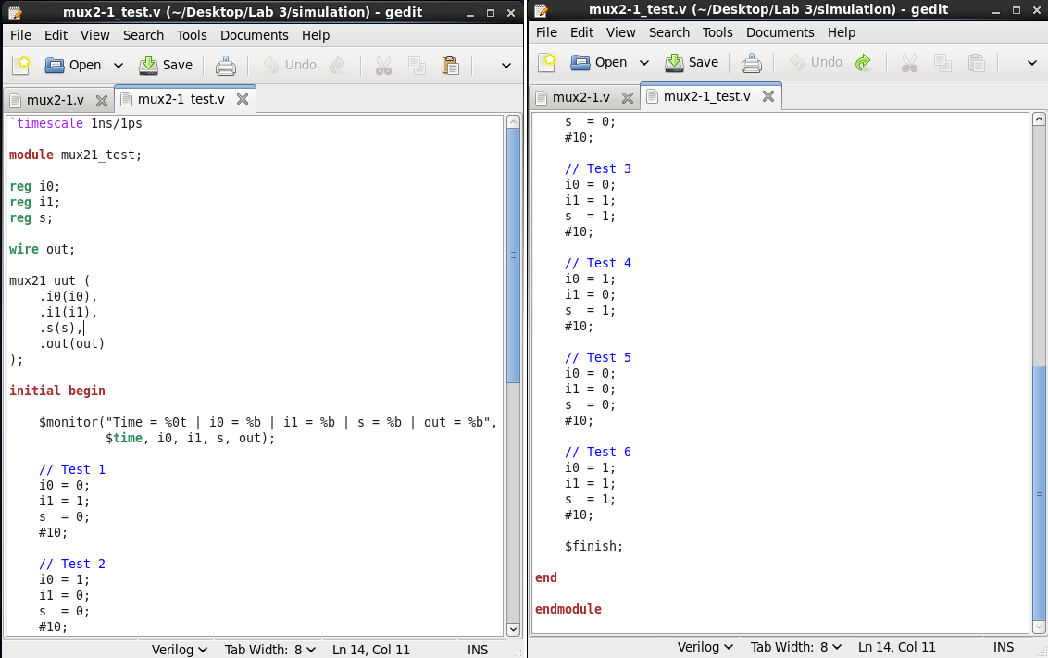

Figure-1.3. NCLaunch window of 2-to-1 Multiplexer showing successful compilation (no errors in the Command Entry Window)
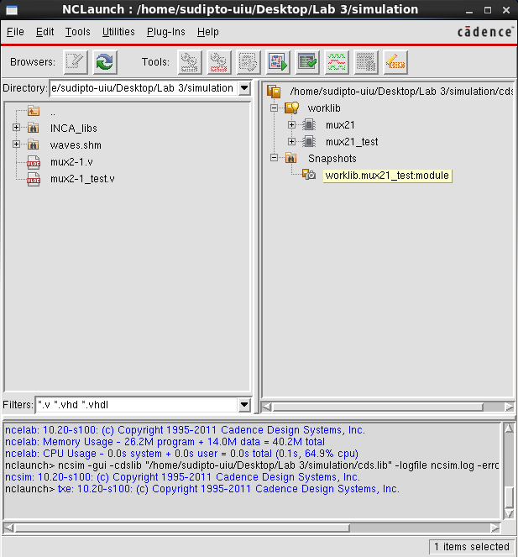

Figure-1.4. SimVision window for 2-to-1 Multiplexer Test-bench, showing the inputs, selector lines, and output
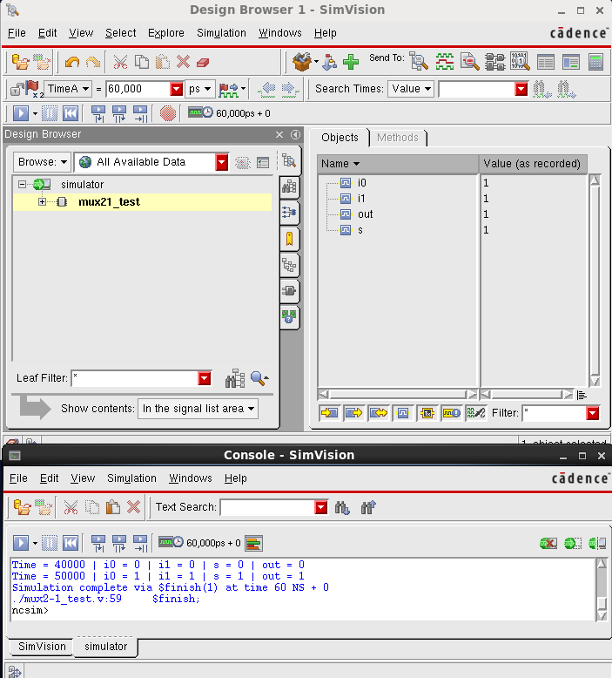

Figure-1.5. SimVision Output Waveform for 2-to-1 Multiplexer Test-bench, showing the inputs, selector lines, and output
